Program1

interface MyInterface

{

public void method1();

public void method2();

}

class Demo implements MyInterface

{

public void method1()

{

System.out.println("implementation of method1");

}

public void method2()

{

System.out.println("implementation of method2");

}

public static void main(String args[])

{

MyInterface obj =new Demo();

obj.method1();

obj.method2();

}

}

Output:

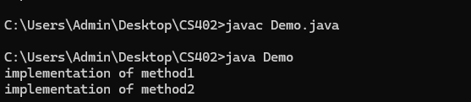

Program 2

interface Animal{

void sound();

void eat();

}

class Dog implements Animal{

public void sound(){

System.out.println("dog barks");

}

public void eat(){

System.out.println("dog eats bones");

}

}

public class Main{

public static void main(String[] args){

Animal myDog =new Dog();

myDog.sound();

myDog.eat();

}

}

Output:  
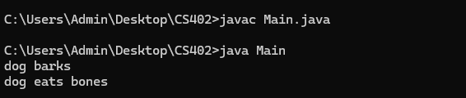

Program3

interface Vehicle{

void start();

}

interface car extends Vehicle{

void drive();

}

class sedan implements car{

public void start(){

System.out.println("sedan is starting");

}

public void drive(){

System.out.println("sedan is driving");

}

}

public class Main1{

public static void main(String [] args){

car myCar = new sedan();

myCar.start();

myCar.drive();

}

}

Output:

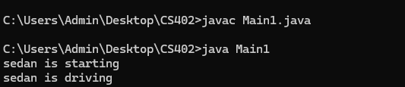

Program 4

interface Printable{

void print();

}

interface showable{

void show();

}

class Document implements Printable,showable{

public void print(){

System.out.println("printing document");

}

public void show(){

System.out.println("showing document preview");

}

}

public class Main2{

public static void main(String [] args){

Document doc = new Document();

doc.print();

doc.show();

}

}

Output:

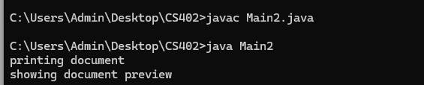

PROGRAM 5

interface Polygon{

default void getPerimeter(){

System.out.println("perimeter:");

}

void getArea();

}

class Rectangle implements Polygon{

int a=10;

int b=15;

public void getPerimeter() {

System.out.println("Perimeter of rectangle: " + 2 \* (a + b));

}

public void getArea() {

System.out.println("Area of rectangle: " + a \* b);

}

}

class circle implements Polygon{

int r=5;

public void getPerimeter() {

System.out.println("Perimeter (Circumference) of circle: " + 2 \* Math.PI \* r);

}

public void getArea() {

System.out.println("Area of circle: " + Math.PI \* r \* r);

}

}

public class Areaa1{

public static void main (String[] args){

Polygon pl= new Rectangle();

pl.getPerimeter();

pl.getArea();

Polygon pll=new circle();

pll.getPerimeter();

pll.getArea();

}

}

OUTPUT:

